**Assisted Practice: 3.17 Create an IAM Group**

This section will guide you to:

* Create an IAM group

This lab has three subsections, namely:

3.17.1 Creating an IAM group

3.17.2 Assigning the required policy to the group

3.17.3 Pushing the files to GitHub repositories

**Step 3.17.1:** Creating an IAM group

* In the IAM panel, click on *Groups*, and you will land on the *Create New Group* page

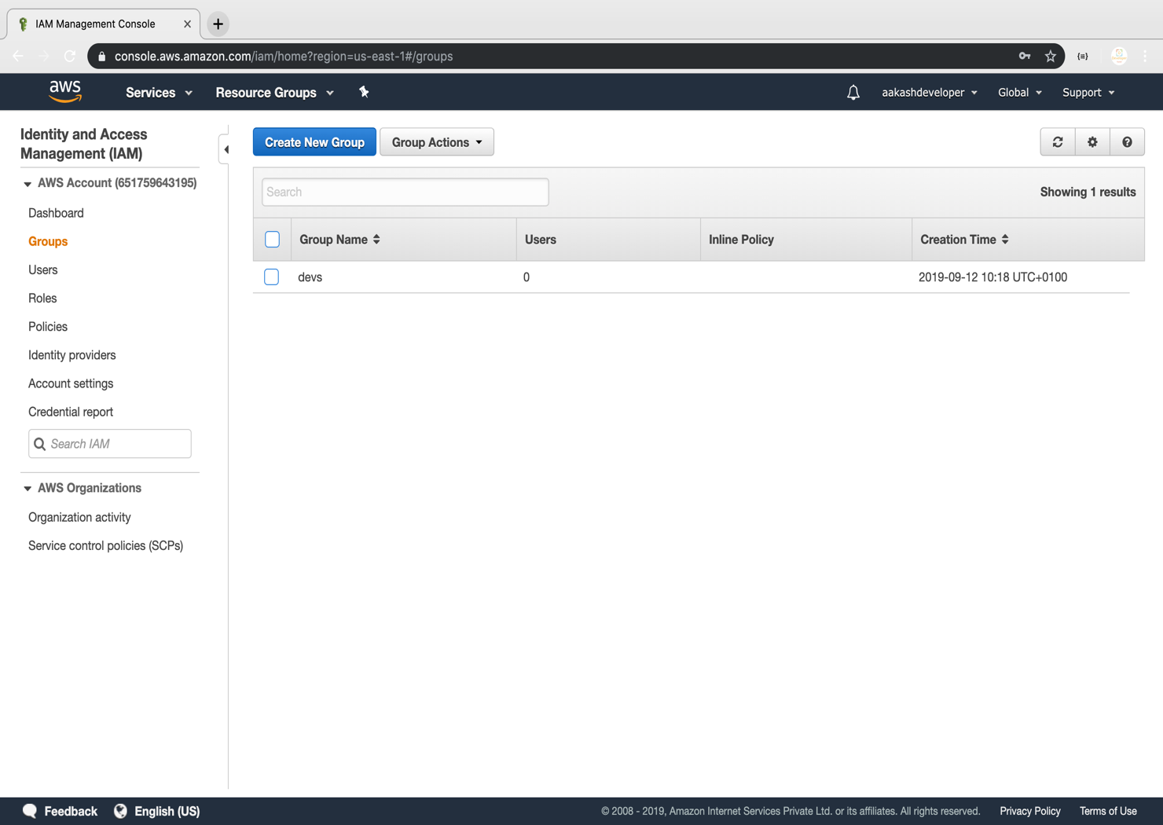

* Enter the group name

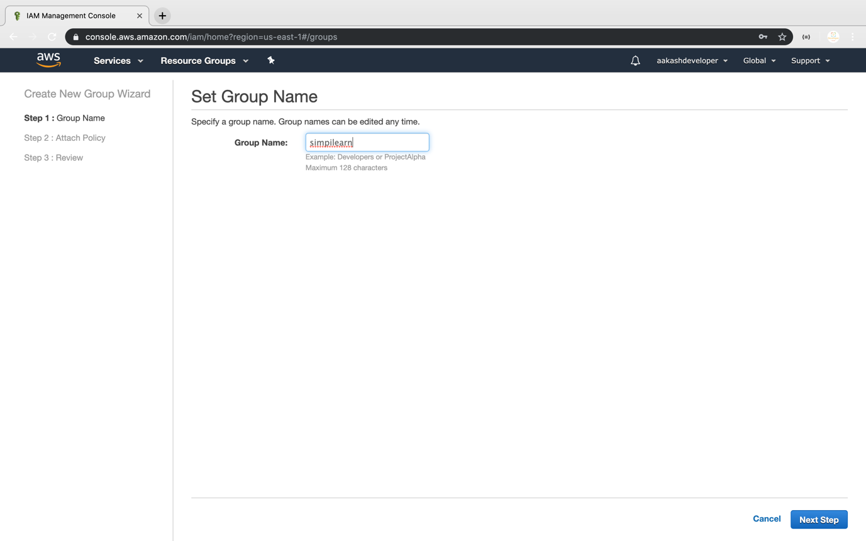

**Step 3.17.2:** Assigning the required policy to the group

* Assign the policy provided by AWS

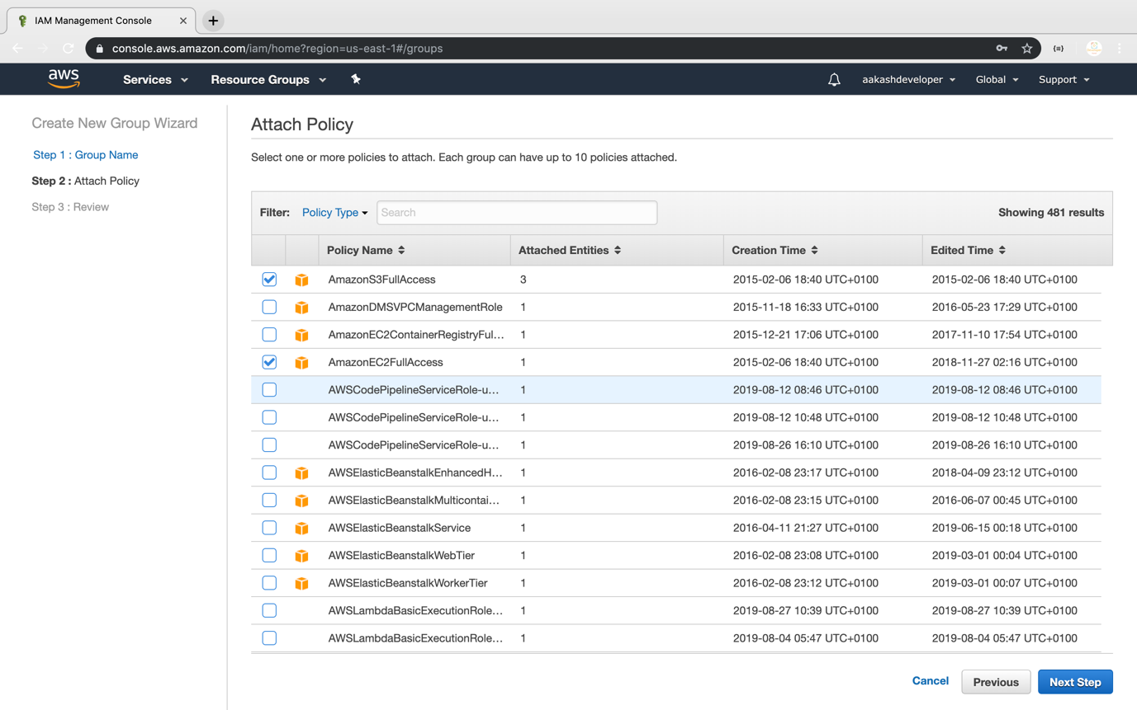

* Once the group is created, you can see the new group in the console

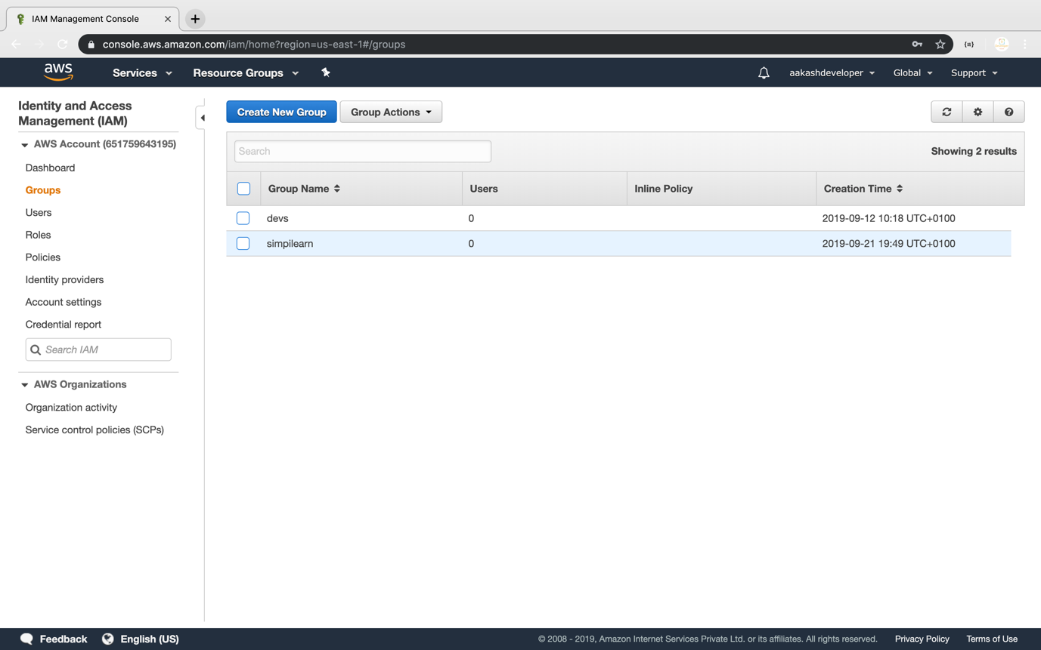

* You can add a user or a policy to the group any time

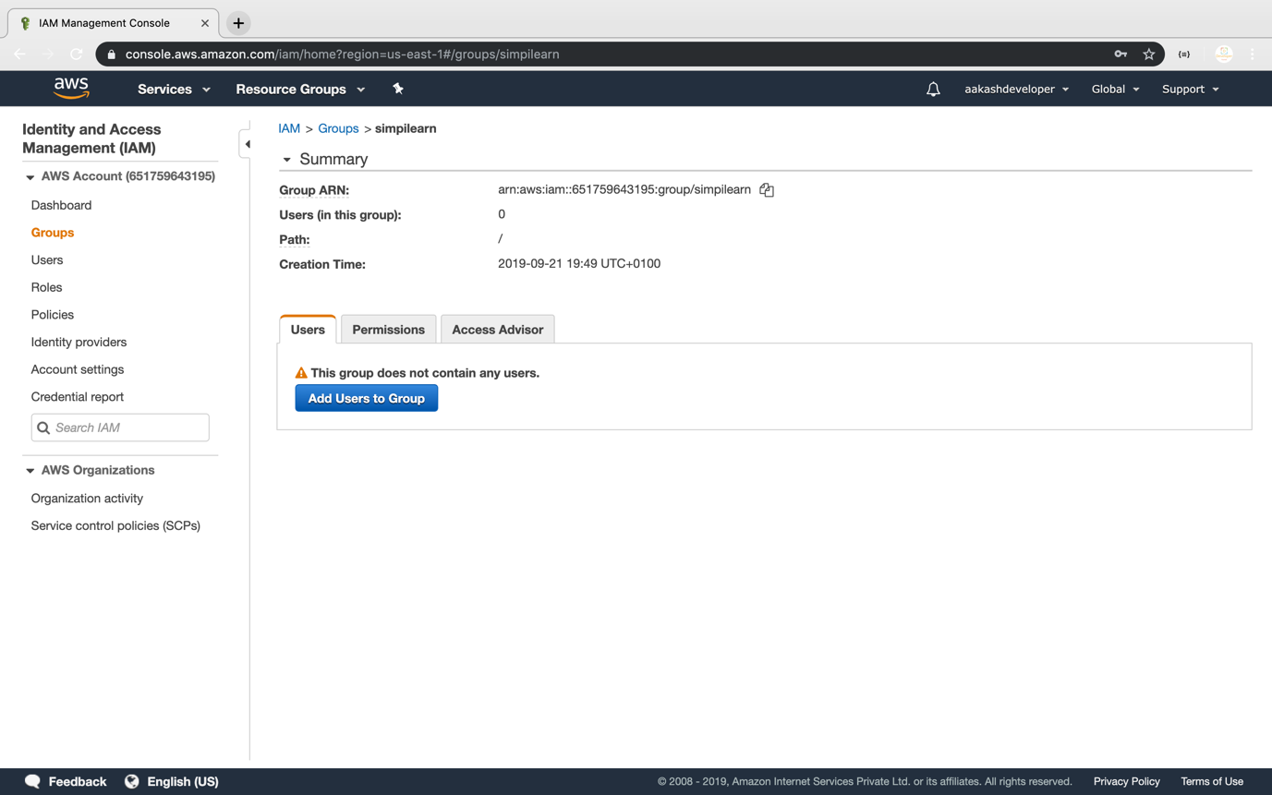

* You can see the user list by clicking on *Add User*

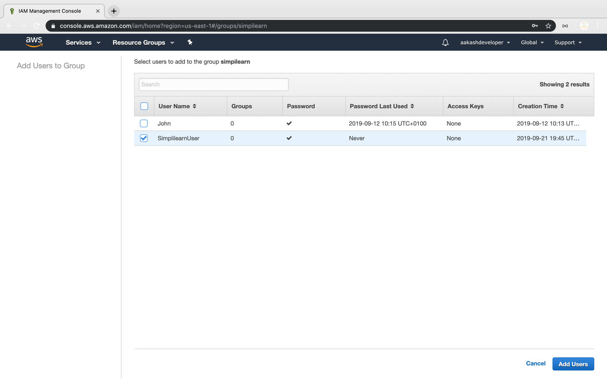

* You can also find all the policies added to the group

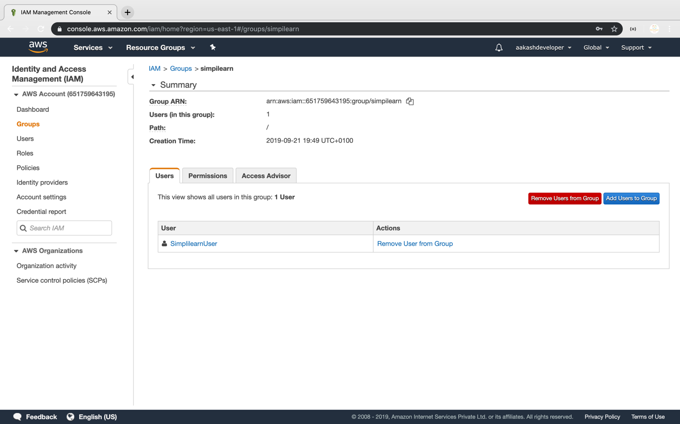

**Step 3.17.3:** Pushing the code to your GitHub repositories

* Open your command prompt and navigate to the folder where you have created your files.

**cd <folder path>**

* Initialize your repository using the following command:

**git init**

* Add all the files to your git repository using the following command:

**git add .**

* Commit the changes using the following command:

**git commit . -m “Changes have been committed.”**

* Push the files to the folder you initially created using the following command:

**git push -u origin master**